Systems Design Interview Concepts (for software engineers / full-stack web)

<https://www.youtube.com/watch?v=REB_eGHK_P4>

Load balancers: help distribute traffic to multiple web servers to help throughput, latency and scalability

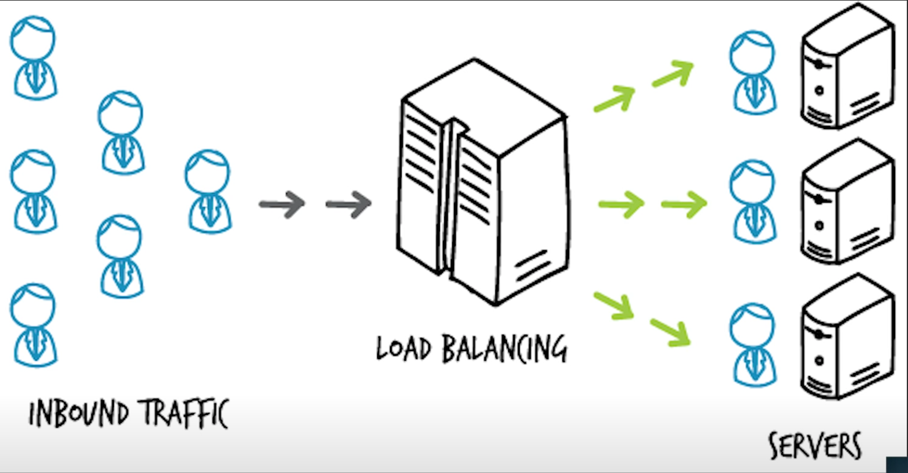

Nginx to route traffic / dns load balancing: given a url have the website route to multiple ip addresses, very simple we don’t need any machine, not much customibility

Web service may not go down but it’s the database – caching

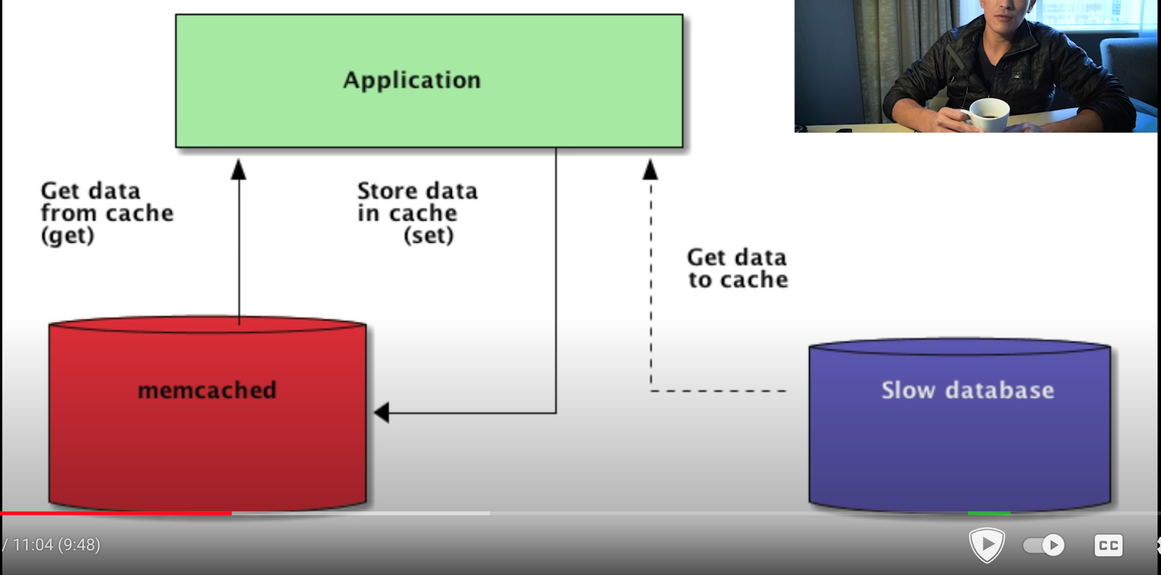

Some caching service are memcached (facebook uses it a lot ) , redis … they are all used in large tech company. In memory cache, it does not have to hit disk so it is efficient we can have the cache last for 24hrs or so

We can also use CDN (content delivery network): save files/css/html.. decrease load on the actual server, also make it faster

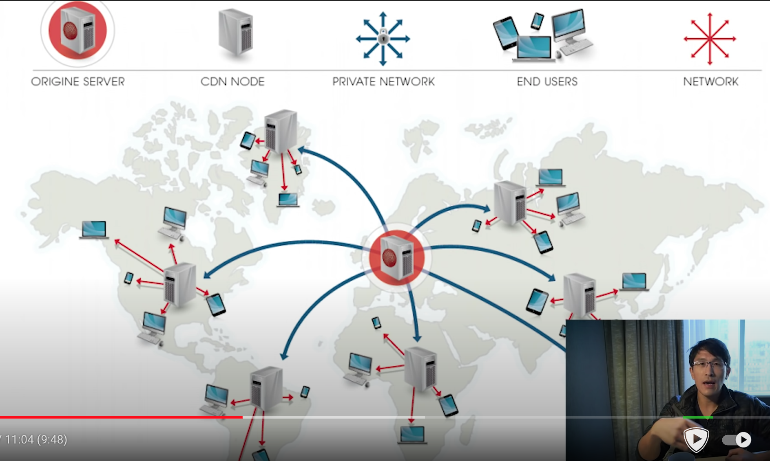

CDN: pull technique, first time user pull the content to CDN and next user can use the content from CDN

Push technique: server push the files to the CDN so it is fast even for the first access but higher cost.

If you allow user to upload image – we need a distributed file system like amazon s3

Database schema: what are the primary keys , what are the indices – make query fast

To avoid database going down:Replication: slave master replication , master to write into, cloned into multiple slave databases where we read from . add 1-2 seconds delay to read, may affect consistency: if write to the database, immediately able to read the same value. In that case, for something like profile that we don’t want delay, we can always read from master database or from a cache.

How to scale:

Web server using load balancer

Image server: use CDN

Database reads:: caching , replication and index, we can have handreds of caching servers and slave servers in order to scale out reads

Database writes: database sharding : split the database into multiple master databases:

vertical sharding: take each table and put in a new machine: you may have a user table, a tweets table, a comments table, a user supports table, a chat table, each is in different machine, that can work well.

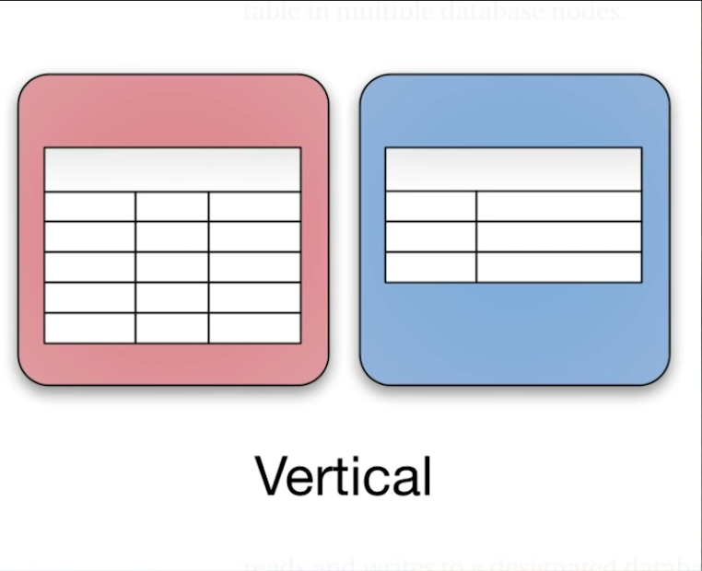

But what if you have a single tweets table and it is going very large how do we handle that? That’s horizontal sharding: you take a single table and you split that across multiple machine

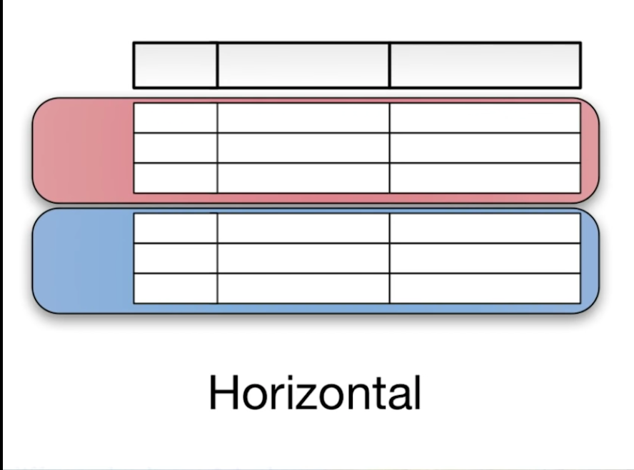

there are multiple ways to do this, one common way you take the user id just multiply by the total number of the machines you want to allocate the user id to. say if you five master machines for a table, you just take the user id , multiply by 5, routes each user to a different machine

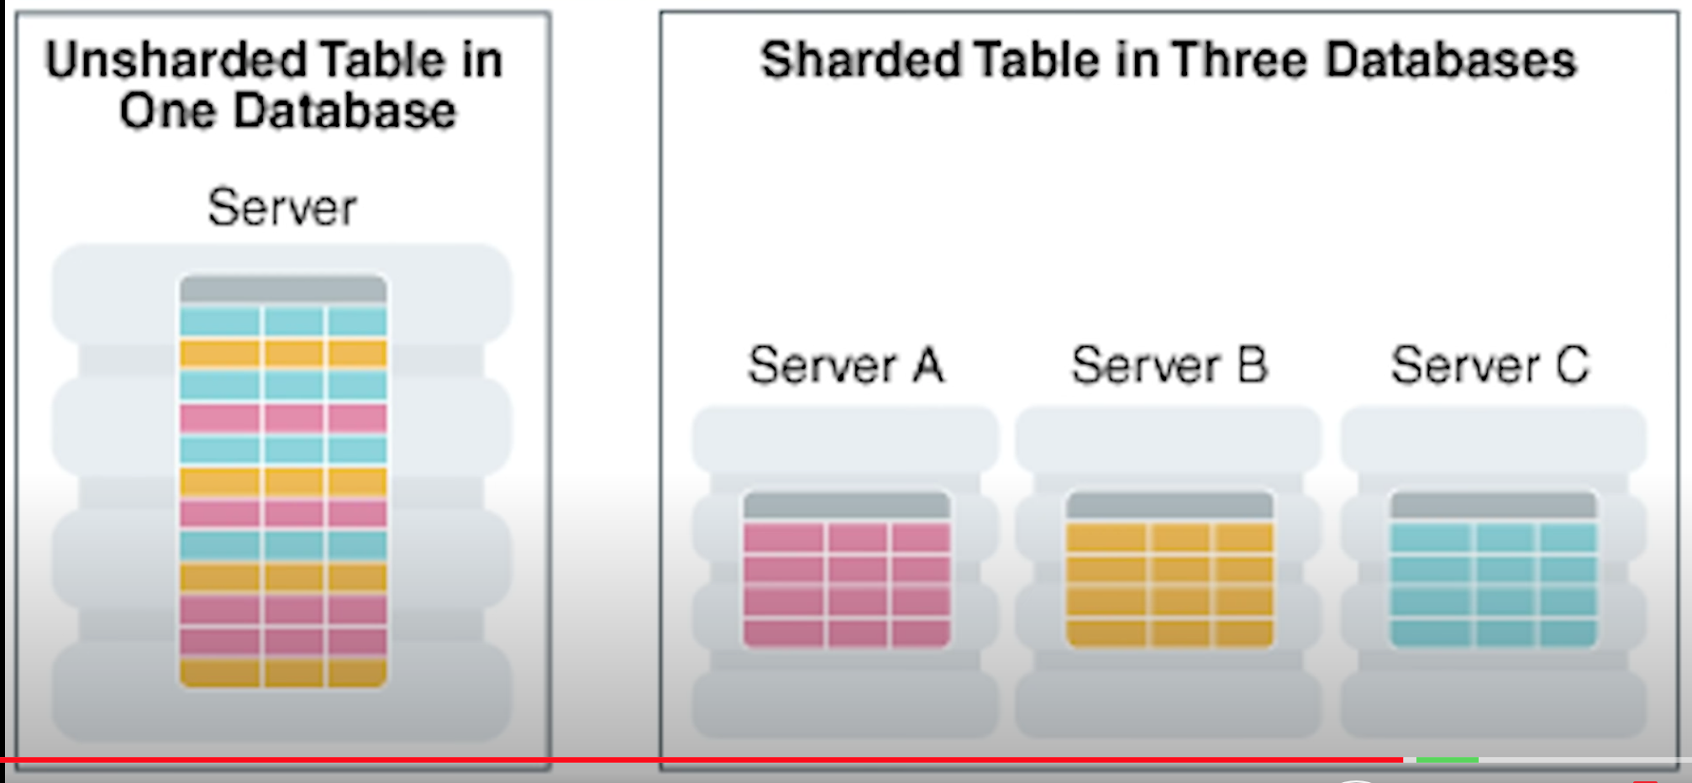

Another way: master table which indicated for each user which machine it will be located on. This master table is responsible for the sharding algorithm

Nosql: not relational. Key value pairs, naturally able to scale automatically by themselves across multiple machines. Easily. Mongodb, amazon’s dynamodb or fire base fire store.

You can use hybrid of these to scale up. If you have active chat server, you could be using nosql engine or simply in memory table. And for your more persistent needs like user table you can use standard relational database like mysql

API design: you may have a client and server. How do they communicate with each other what are the functions and methods they use. What is the data transport mechanism are you using json or protocol bufferes what does the data look like how do you handle security, do you support offline usage. How do you make it fast. Its open ended. Depending on the application and user senarios and where your load is going to be. No two applications are going to scale exactly the same way. Which is why it is important to ask a lot of clarifying questions and figure out what type of load and scenario the system will be put under. You never want to scale too early or put in premature optimizations. Because it just complicate the system. The things people value the most is simplicity.

Zheng li is reading system design interview – an insider's guide: volume 2

system design interview – an insider's guide edition 2:

**CHAPTER 1: SCALE FROM ZERO TO MILLIONS OF USERS**

Single server:

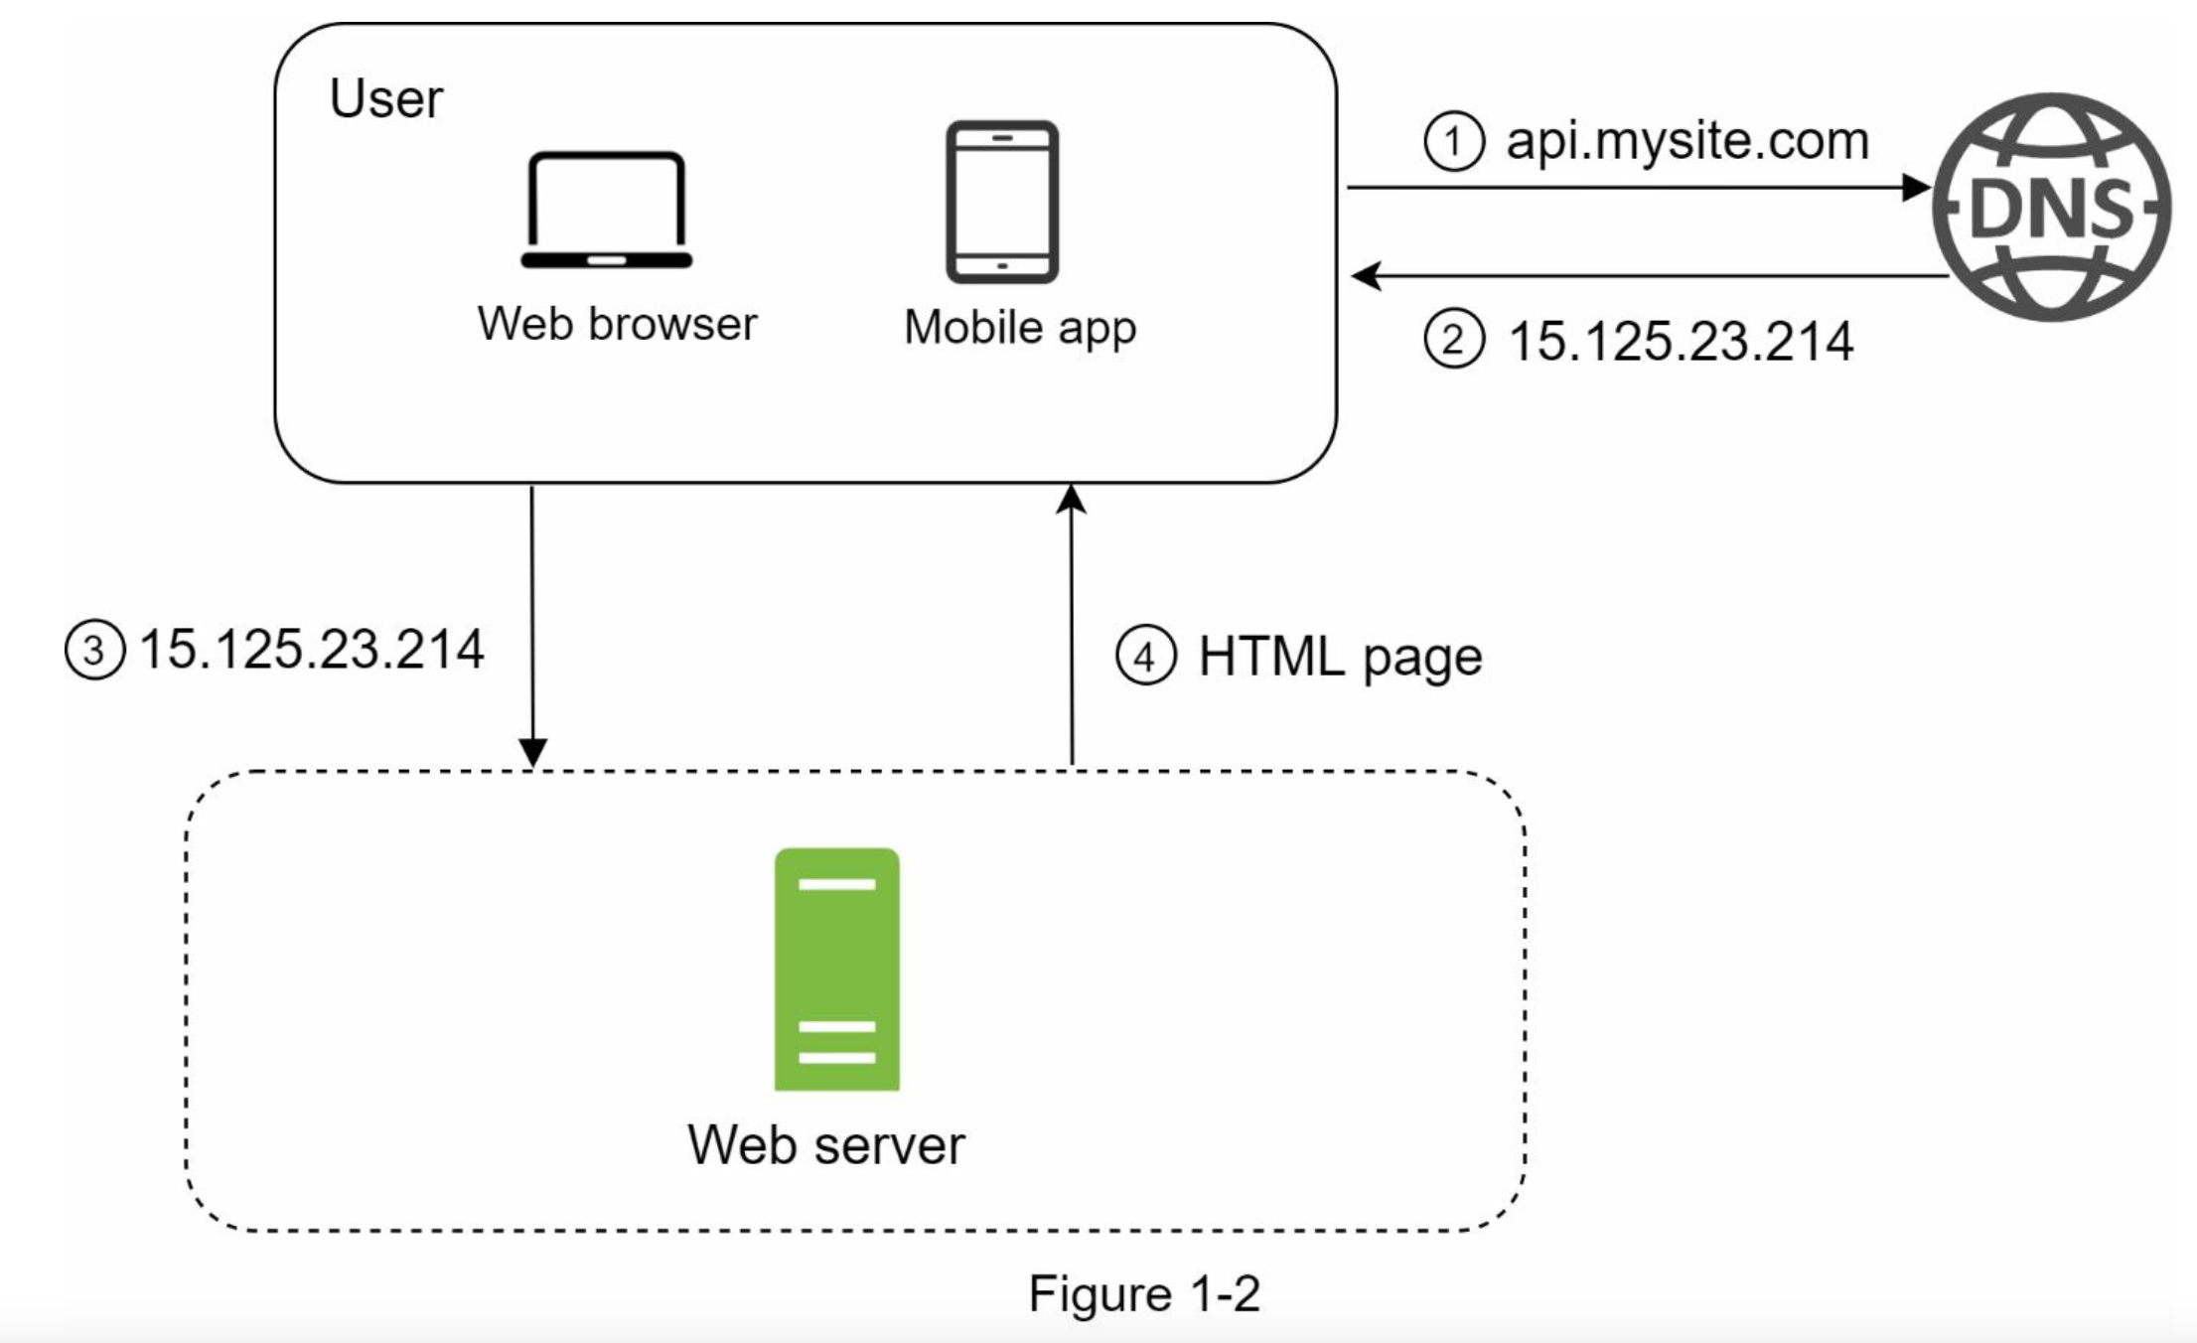

+ database server

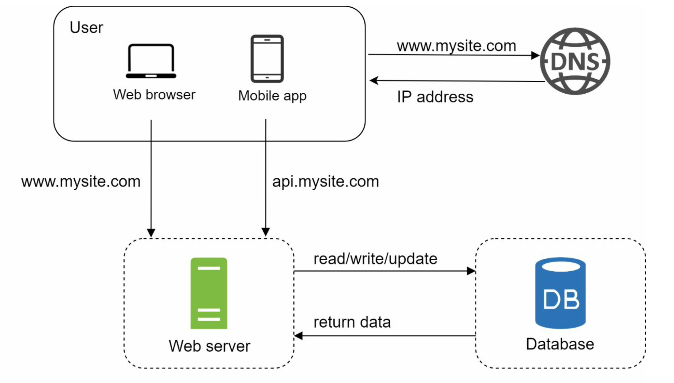

Relational databases are also called a relational database management system (RDBMS) or SQL database. The most popular ones are MySQL, Oracle database, PostgreSQL, etc. Relational databases represent and store data in tables and rows. You can perform join operations using SQL across different database tables.

Non-Relational databases are also called NoSQL databases. Popular ones are CouchDB, Neo4j, Cassandra, HBase, Amazon DynamoDB, etc. [2]. These databases are grouped into four categories: key-value stores, graph stores, column stores, and document stores. Join operations are generally not supported in non-relational databases.

For most developers, relational databases are the best option because they have been around for over 40 years and historically, they have worked well. However, if relational databases are not suitable for your specific use cases, it is critical to explore beyond relational databases. Non-relational databases might be the right choice if:

• Your application requires super-low latency.

• Your data are unstructured, or you do not have any relational data.

 • You only need to serialize and deserialize data (JSON, XML, YAML, etc.).

• You need to store a massive amount of data.

Vertical scaling, referred to as “scale up”, means the process of adding more power (CPU, RAM, etc.) to your servers. Horizontal scaling, referred to as “scale-out”, allows you to scale by adding more servers into your pool of resources.

When traffic is low, vertical scaling is a great option, and the simplicity of vertical scaling is its main advantage. Unfortunately, it comes with serious limitations.

• Vertical scaling has a hard limit. It is impossible to add unlimited CPU and memory to a single server.

• Vertical scaling does not have failover and redundancy. If one server goes down, the website/app goes down with it completely.

Horizontal scaling is more desirable for large scale applications due to the limitations of vertical scaling.

A load balancer is the best technique to address these problems.

A load balancer evenly distributes incoming traffic among web servers that are defined in a load-balanced set.

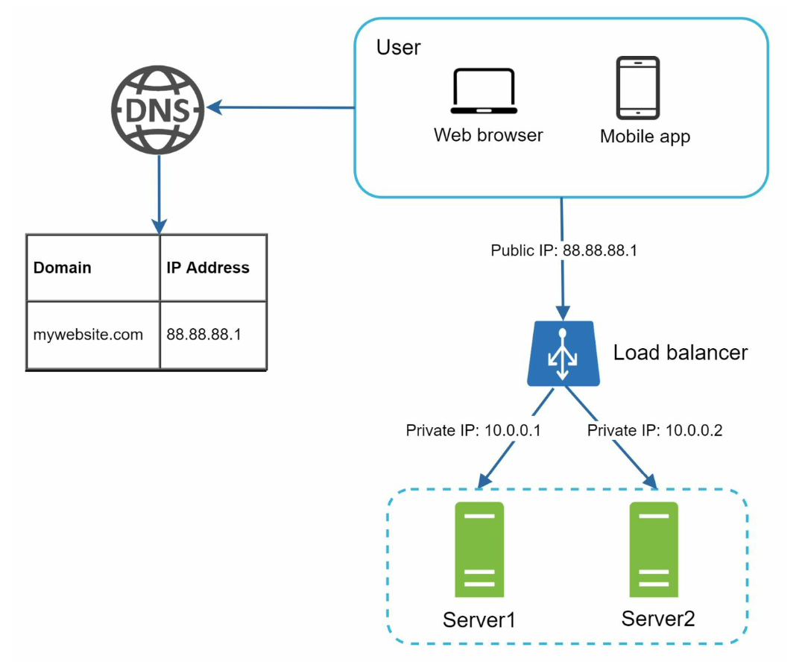

For better security, private IPs are used for communication between servers. A private IP is an IP address reachable only between servers in the same network; however, it is unreachable over the internet. The load balancer communicates with web servers through private IPs.

after a load balancer and a second web server are added, we successfully solved no failover issue and improved the availability of the web tier. Details are explained below:

• If server 1 goes offline, all the traffic will be routed to server 2. This prevents the website from going offline. We will also add a new healthy web server to the server pool to balance the load.

• If the website traffic grows rapidly, and two servers are not enough to handle the traffic, the load balancer can handle this problem gracefully. You only need to add more servers to the web server pool, and the load balancer automatically starts to send requests to them.

The current design has one database , so it does not support failover and redundancy. Database replication is a common technique to address those problems.

Database replication can be used in many database management systems, usually with a master/slave relationship between the original (master) and the copies (slaves)

A master database generally only supports write operations. A slave database gets copies of the data from the master database and only supports read operations.

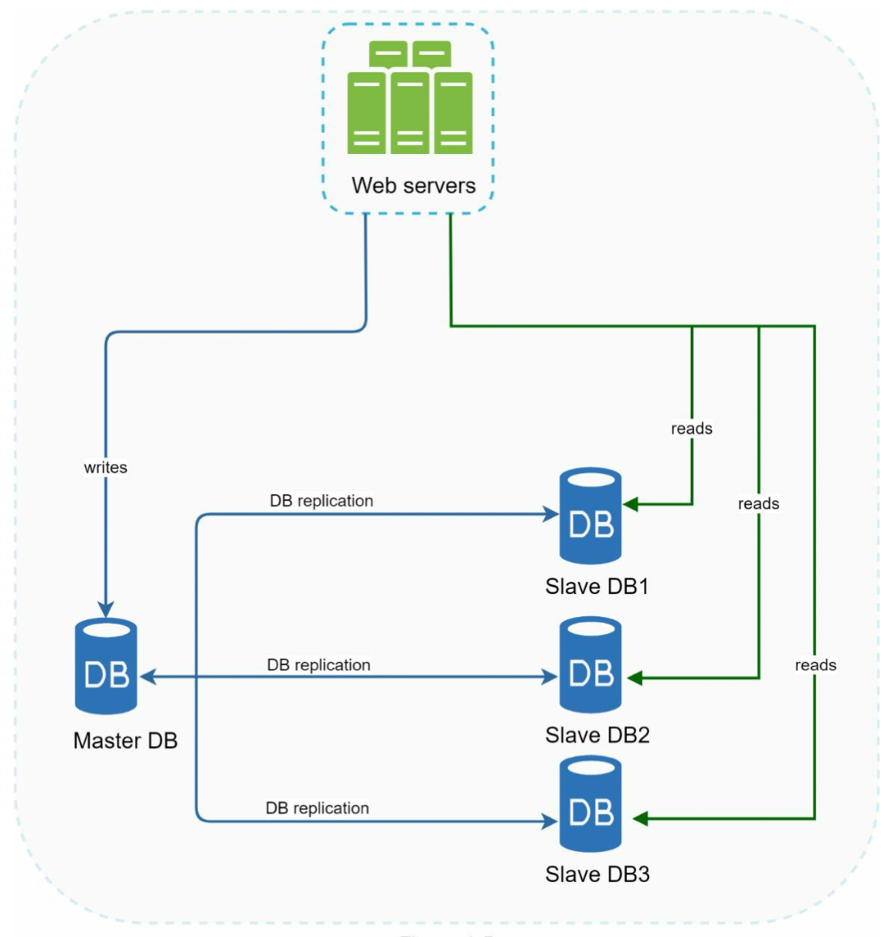

Advantages of database replication:

• Better performance: In the master-slave model, all writes and updates happen in master nodes; whereas, read operations are distributed across slave nodes. This model improves performance because it allows more queries to be processed in parallel.

• Reliability: If one of your database servers is destroyed by a natural disaster, such as a typhoon or an earthquake, data is still preserved. You do not need to worry about data loss because data is replicated across multiple locations.

• High availability: By replicating data across different locations, your website remains in operation even if a database is offline as you can access data stored in another database server.

what if one of the databases goes offline?

• If only one slave database is available and it goes offline, read operations will be directed to the master database temporarily. As soon as the issue is found, a new slave database will replace the old one. In case multiple slave databases are available, read operations are redirected to other healthy slave databases. A new database server will replace the old one.

• If the master database goes offline, a slave database will be promoted to be the new master. All the database operations will be temporarily executed on the new master database. A new slave database will replace the old one for data replication immediately. In production systems, promoting a new master is more complicated as the data in a slave database might not be up to date. The missing data needs to be updated by running data recovery scripts. Although some other replication methods like multi-masters and circular replication could help, those setups are more complicated

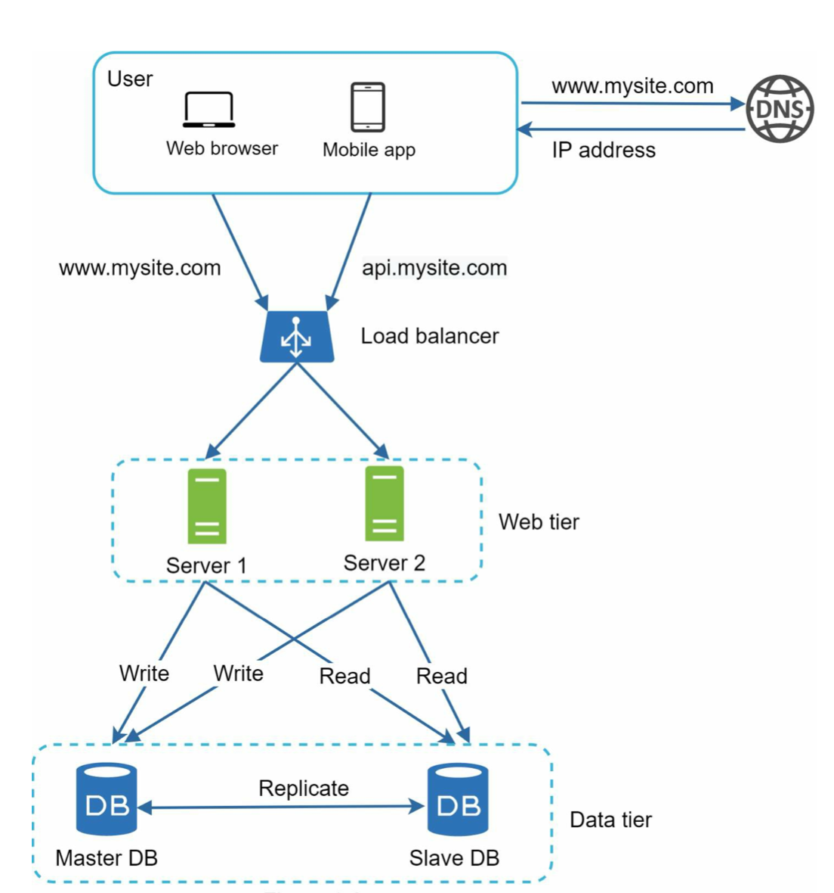

Now, you have a solid understanding of the web and data tiers, it is time to improve the load/response time. This can be done by adding a cache layer and shifting static content (JavaScript/CSS/image/video files) to the content delivery network (CDN).

A cache is a temporary storage area that stores the result of expensive responses or frequently accessed data in memory so that subsequent requests are served more quickly.

The cache tier is a temporary data store layer, much faster than the database. The benefits of having a separate cache tier include better system performance, ability to reduce database workloads, and the ability to scale the cache tier independently.

Figure 1-7 shows a possible setup of a cache server:

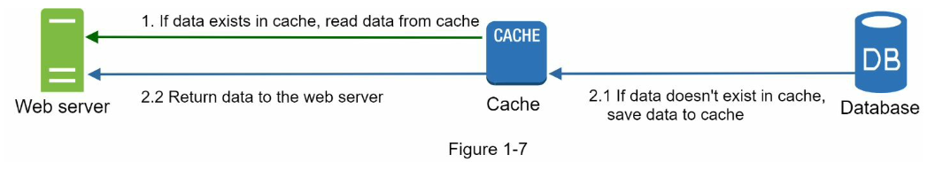

Interacting with cache servers is simple because most cache servers provide APIs for common programming languages. The following code snippet shows typical Memcached APIs:

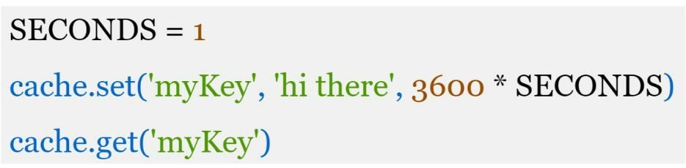

Here are a few considerations for using a cache system:

• Decide when to use cache. Consider using cache when data is read frequently but modified infrequently. Since cached data is stored in volatile memory, a cache server is not ideal for persisting data.

• Expiration policy. It is a good practice to implement an expiration policy. Once cached data is expired, it is removed from the cache. When there is no expiration policy, cached data will be stored in the memory permanently. It is advisable not to make the expiration date too short as this will cause the system to reload data from the database too frequently. Meanwhile, it is advisable not to make the expiration date too long as the data can become stale.

• Consistency: This involves keeping the data store and the cache in sync. Inconsistency can happen because data-modifying operations on the data store and cache are not in a single transaction. When scaling across multiple regions, maintaining consistency between the data store and cache is challenging**.** For further details, refer to the paper titled “Scaling Memcache at Facebook” published by Facebook [7].

• Mitigating failures: A single cache server represents a potential single point of failure (SPOF), defined in Wikipedia as follows: “A single point of failure (SPOF) is a part of a system that, if it fails, will stop the entire system from working” [8]. As a result, multiple cache servers across different data centers are recommended to avoid SPOF. Another recommended approach is to overprovision the required memory by certain percentages. This provides a buffer as the memory usage increases.

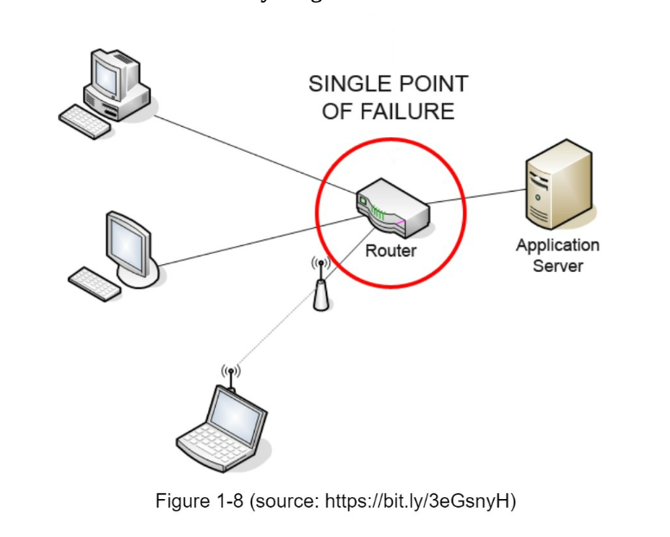

• Eviction Policy: Once the cache is full, any requests to add items to the cache might cause existing items to be removed. This is called cache eviction. Least-recently-used (LRU) is the most popular cache eviction policy. Other eviction policies, such as the Least Frequently Used (LFU) or First in First Out (FIFO), can be adopted to satisfy different use cases.

A CDN is a network of geographically dispersed servers used to deliver static content. CDN servers cache static content like images, videos, CSS, JavaScript files, etc.

CDN improves load time.

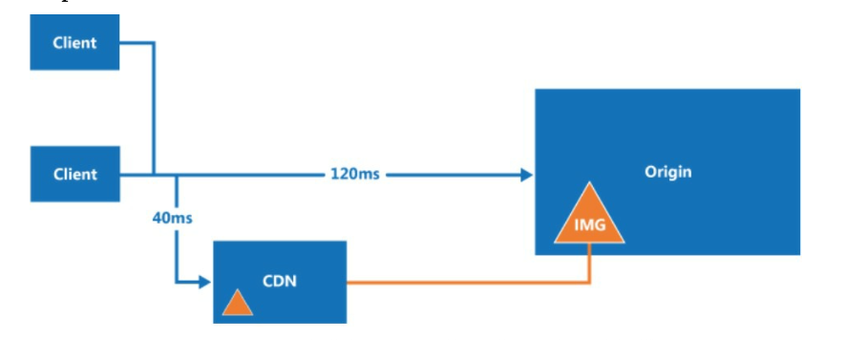

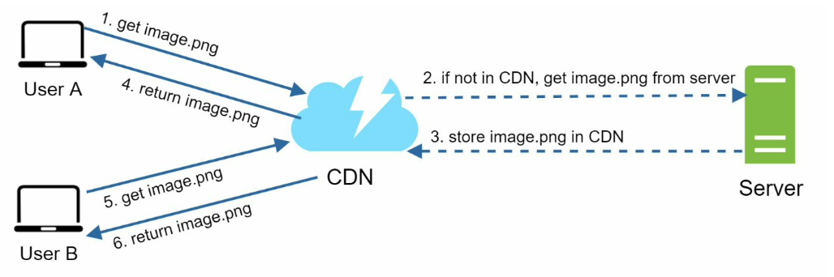

The image remains cached in the CDN until the TTL expires.

**Considerations of using a CDN**

• Cost: CDNs are run by third-party providers, and you are charged for data transfers in and out of the CDN. Caching infrequently used assets provides no significant benefits so you should consider moving them out of the CDN.

• Setting an appropriate cache expiry: For time-sensitive content, setting a cache expiry time is important. The cache expiry time should neither be too long nor too short. If it is too long, the content might no longer be fresh. If it is too short, it can cause repeat reloading of content from origin servers to the CDN.

• CDN fallback: You should consider how your website/application copes with CDN failure. If there is a temporary CDN outage, clients should be able to detect the problem and request resources from the origin.

• Invalidating files: You can remove a file from the CDN before it expires by performing one of the following operations:

• Invalidate the CDN object using APIs provided by CDN vendors.

• Use object versioning to serve a different version of the object. To version an object, you can add a parameter to the URL, such as a version number. For example, version number 2 is added to the query string: image.png?v=2.

the design after the CDN and cache are added：

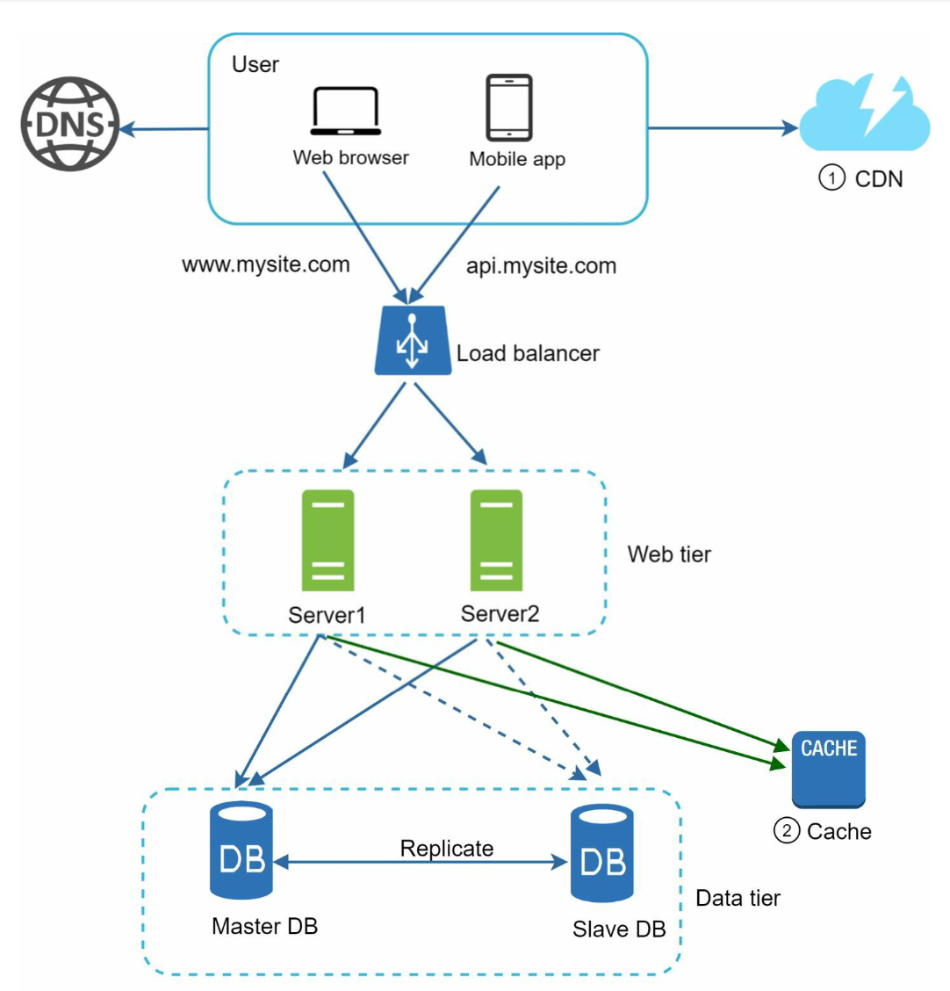

1. Static assets (JS, CSS, images, etc.,) are no longer served by web servers. They are fetched from the CDN for better performance.

2. The database load is lightened by caching data.

stateful architecture

A stateful server remembers client data (state) from one request to the next

The issue is that every request from the same client must be routed to the same server. This can be done with sticky sessions in most load balancers [10]; however, this adds the overhead. Adding or removing servers is much more difficult with this approach. It is also challenging to handle server failures.

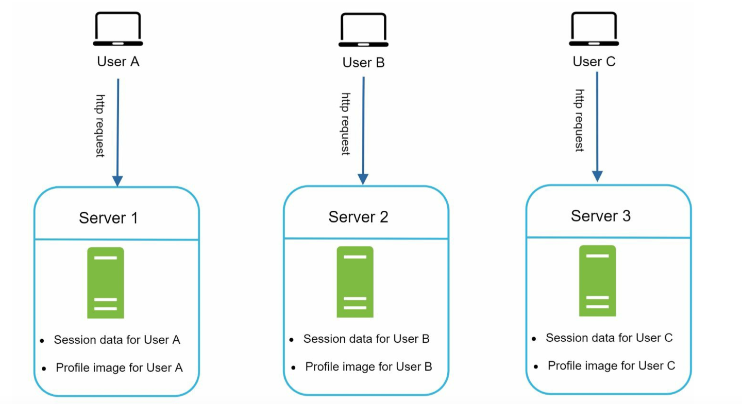

Stateless architecture ：

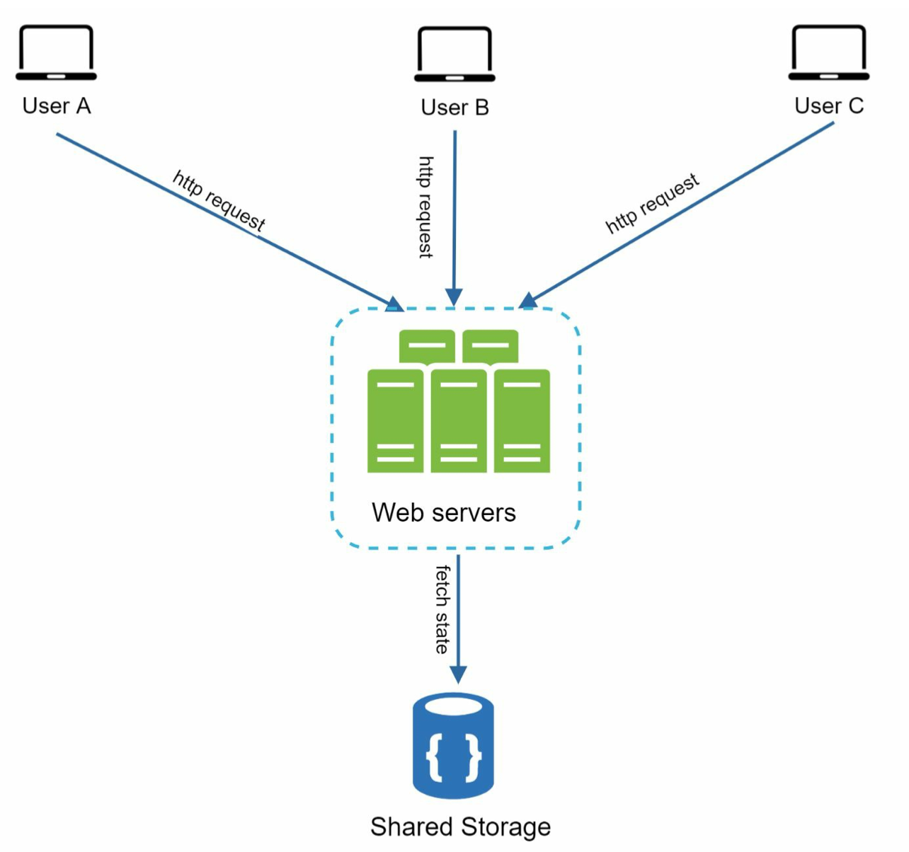

updated design with a stateless web tier

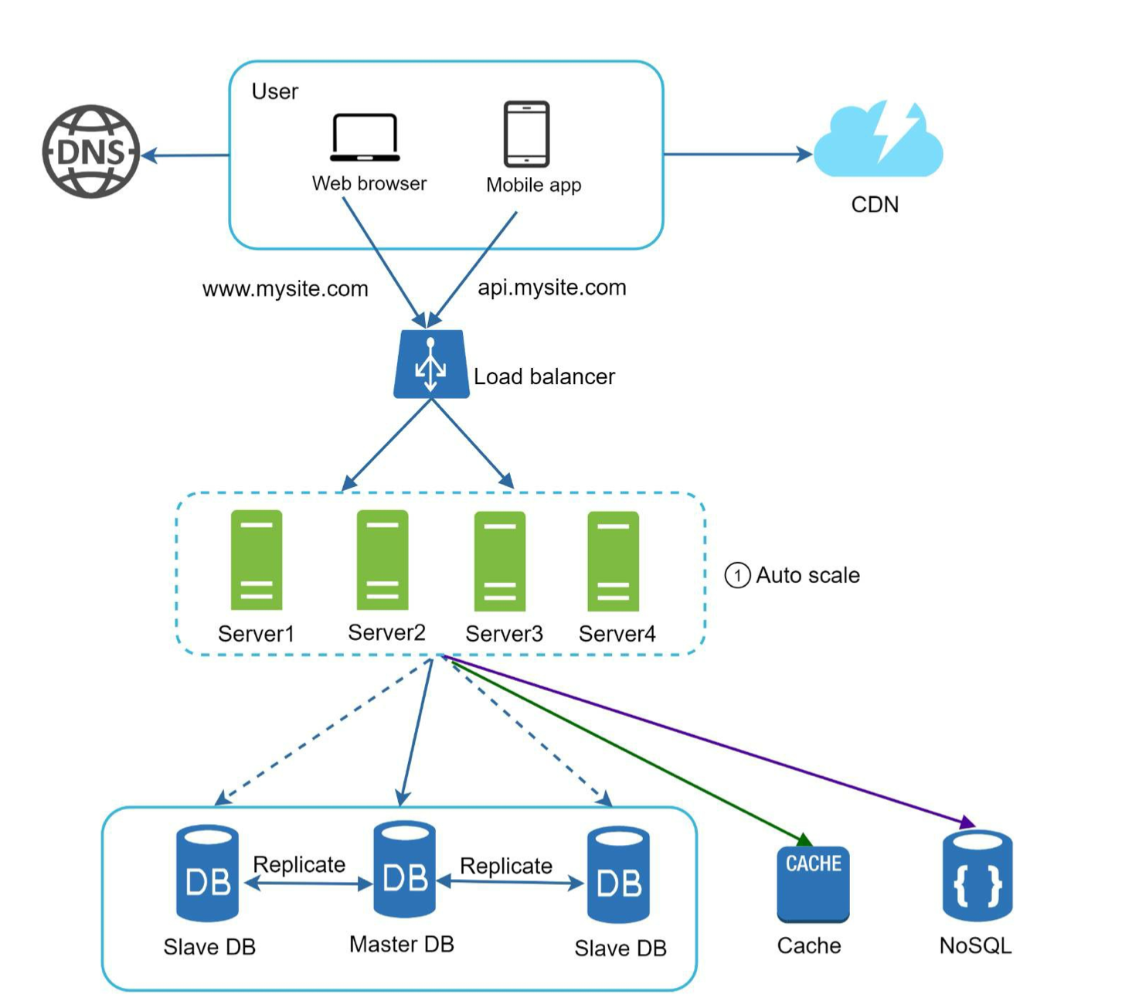

we move the session data out of the web tier and store them in the persistent data store. The shared data store could be a relational database, Memcached/Redis, NoSQL, etc. The NoSQL data store is chosen as it is easy to scale. Autoscaling means adding or removing web servers automatically based on the traffic load.

<https://medium.com/@t0ri/being-stateful-in-a-stateless-web-8185ed777048>

[The stateless web exists purposefully by design](https://restfulapi.net/statelessness/), but it can also be a restriction. If the server doesn’t store any information about what the client is up to, how did Medium remember you were logged in when you navigated to this page? Moreso, how did the server know *which*account you were logged into?

HTTP as “a stateless application-level protocol”.

because HTTP is stateless, the *server* doesn’t automatically know your information when you click a link and ask to be served a new response

The preferred solution is to use cookies to store a Session Id 🏷️ locally, but save the session data on server-side. An HTTP request can pass the Id from your cookies in your GET request, be looked up in a database of thousands of states from all clients 🗃️, and have the state sent back.

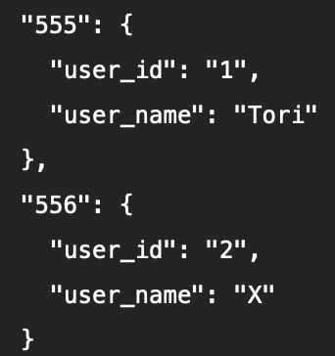

With Session Ids, the server is constantly creating and destroying states. Each state for each client at many different moments is being saved, and the Session Id stored in your cookies will be rewritten to reflect where your state is currently saved. Session data stored on a server is kept in key-value pairs, where 555 is my Session Id and 556 is yours.

Now when we send out that HTTP request asking for my Medium article, the conversation from before may look a little more like this:

**Client**: Hey, can you GET this article for session 555?  
**Server**: Of course, {555.user_name}! Coming right up!

Session Ids are preferred because the actual values and data is hidden from the client, not to mention that the developers are in control of the data and its expiration.

To improve availability and provide a better user experience across wider geographical areas, supporting multiple data centers is crucial.

an example setup with two data centers:

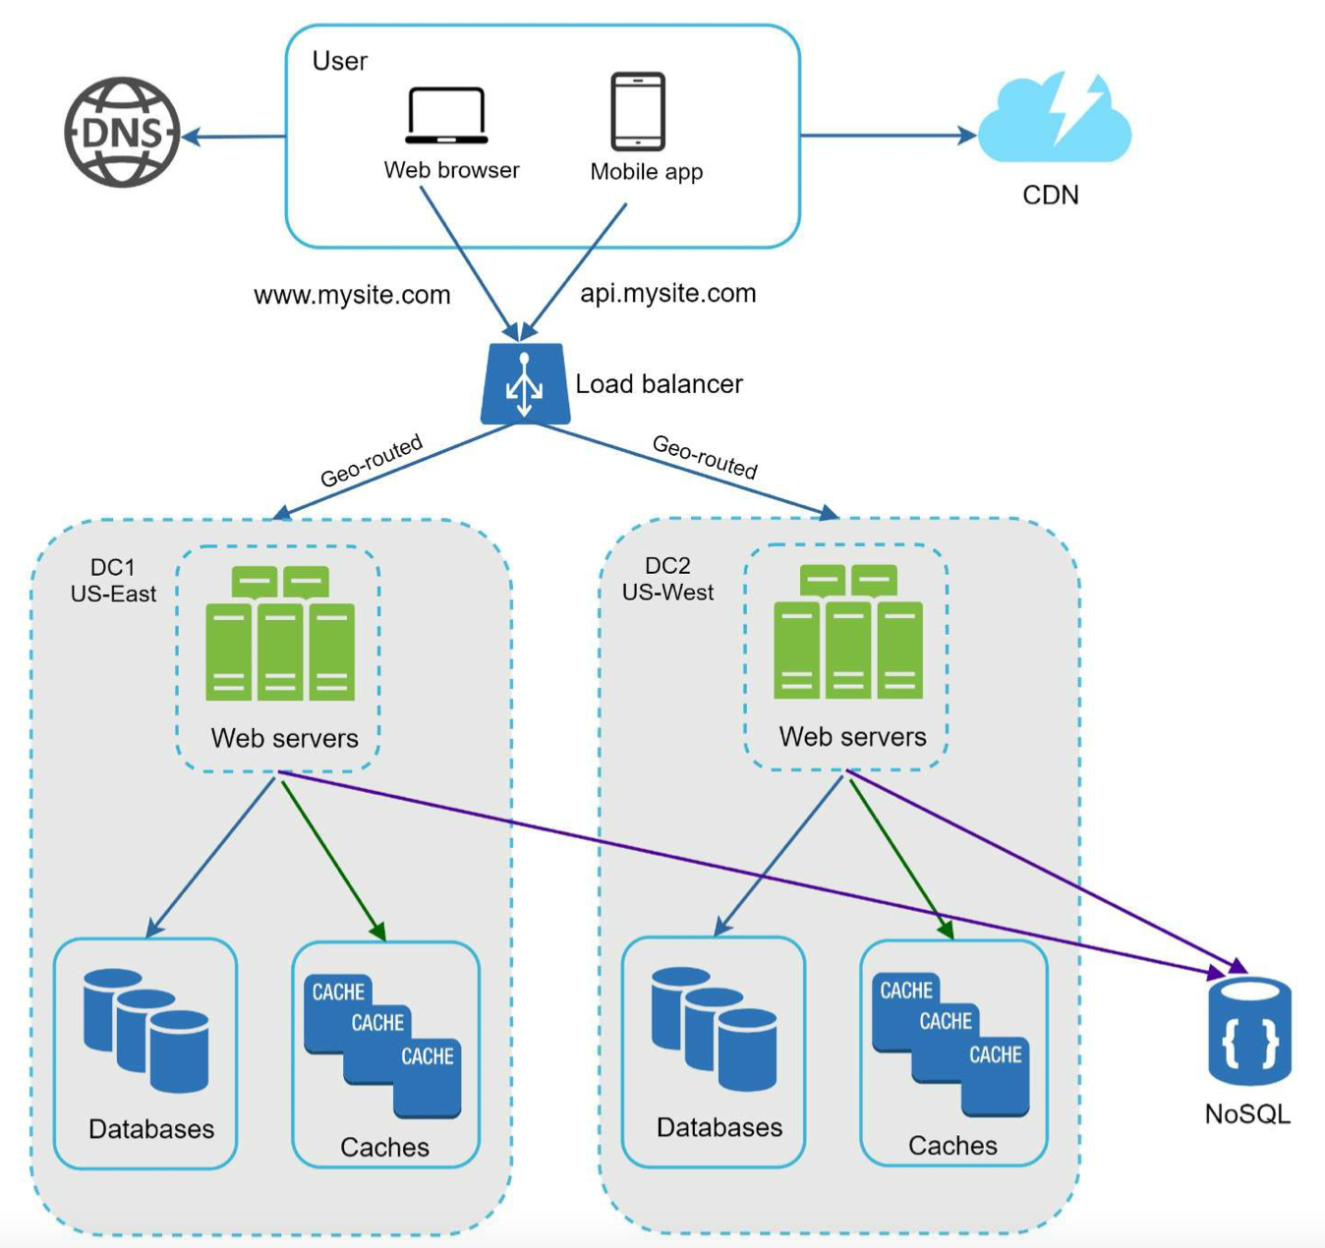

In normal operation, users are geoDNS-routed, also known as geo-routed, to the closest data center, with a split traffic of *x%* in US-East and *(100 – x)%* in US-West. geoDNS is a DNS service that allows domain names to be resolved to IP addresses based on the location of a user.

In the event of any significant data center outage, we direct all traffic to a healthy data center:

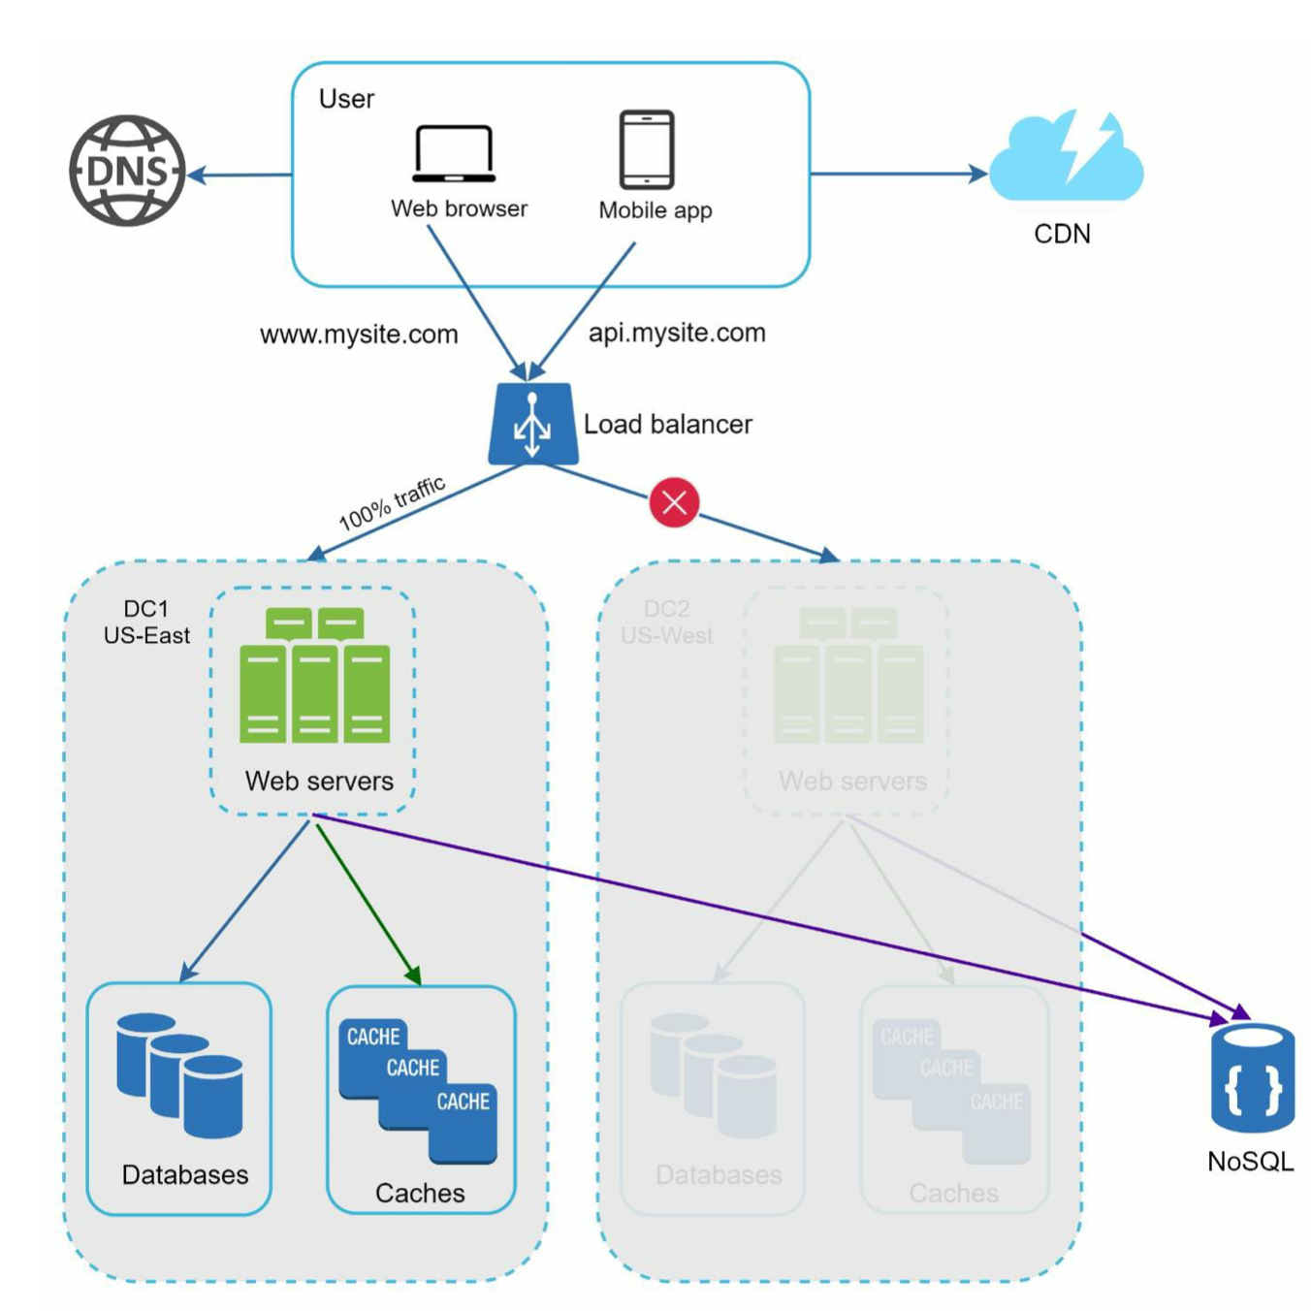

Several technical challenges must be resolved to achieve multi-data center setup:

• Traffic redirection: Effective tools are needed to direct traffic to the correct data center. GeoDNS can be used to direct traffic to the nearest data center depending on where a user is located.

• Data synchronization: Users from different regions could use different local databases or caches. In failover cases, traffic might be routed to a data center where data is unavailable. A common strategy is to replicate data across multiple data centers. A previous study shows how Netflix implements asynchronous multi-data center replication [11].

• Test and deployment: With multi-data center setup, it is important to test your website/application at different locations. Automated deployment tools are vital to keep services consistent through all the data centers [11].

**Message queue**

To further scale our system, we need to decouple different components of the system so they can be scaled independently. Messaging queue is a key strategy employed by many real- world distributed systems to solve this problem.

A message queue is a durable component, stored in memory, that supports asynchronous communication.

Input services, called producers/publishers, create messages, and publish them to a message queue. Other services or servers, called consumers/subscribers, connect to the queue, and perform actions defined by the messages.

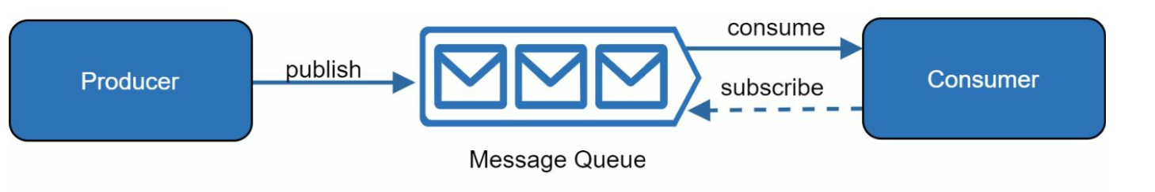

e.g. The producer and the consumer can be scaled independently. When the size of the queue becomes large, more workers are added to reduce the processing time. However, if the queue is empty most of the time, the number of workers can be reduced.

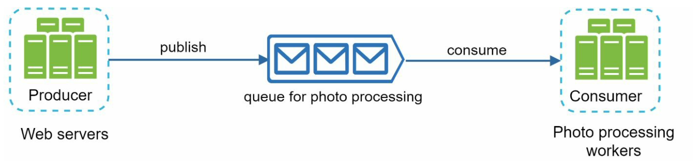

Logging: Monitoring error logs is important because it helps to identify errors and problems in the system. You can monitor error logs at per server level or use tools to aggregate them to a centralized service for easy search and viewing.

Metrics: Collecting different types of metrics help us to gain business insights and understand the health status of the system. Some of the following metrics are useful:

• Host level metrics: CPU, Memory, disk I/O, etc.

• Aggregated level metrics: for example, the performance of the entire database tier, cache tier, etc.

• Key business metrics: daily active users, retention, revenue, etc.

Automation: When a system gets big and complex, we need to build or leverage automation tools to improve productivity. Continuous integration is a good practice, in which each code check-in is verified through automation, allowing teams to detect problems early. Besides, automating your build, test, deploy process, etc. could improve developer productivity significantly.

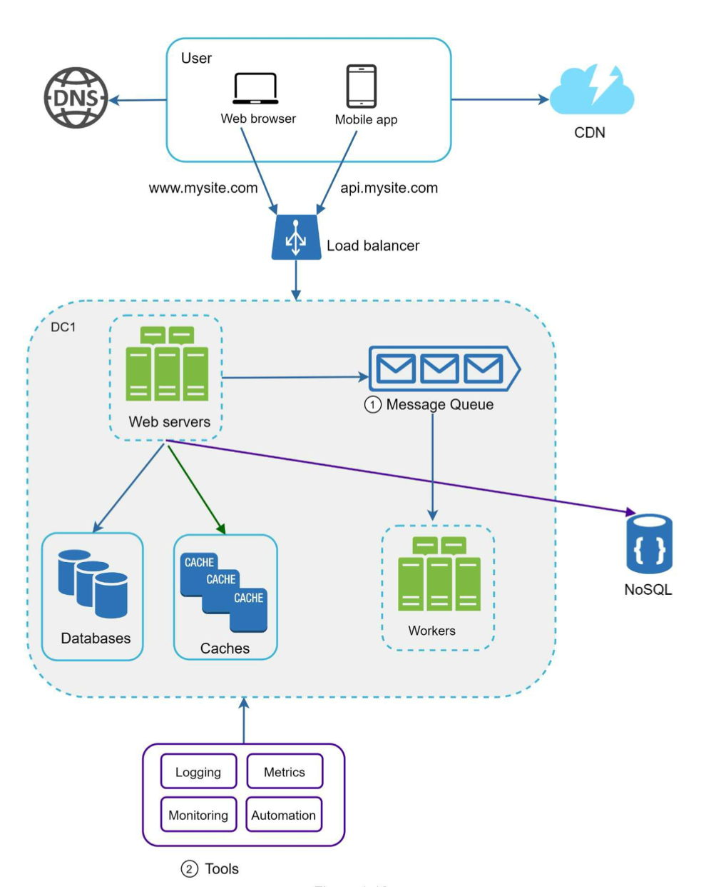

As the data grows every day, your database gets more overloaded. It is time to scale the data tier.

**Database scaling**

Vertical scaling, also known as scaling up, is the scaling by adding more power (CPU, RAM, DISK, etc.) to an existing machine.

However, vertical scaling comes with some serious drawbacks:

• You can add more CPU, RAM, etc. to your database server, but there are hardware limits. If you have a large user base, a single server is not enough.

• Greater risk of single point of failures. • The overall cost of vertical scaling is high. Powerful servers are much more expensive.

Horizontal scaling, also known as sharding, is the practice of adding more servers.

Sharding separates large databases into smaller, more easily managed parts called shards. Each shard shares the same schema, though the actual data on each shard is unique to the shard.

an example of sharded databases. User data is allocated to a database server based on user IDs. Anytime you access data, a hash function is used to find the corresponding shard. In our example, *user_id % 4* is used as the hash function.

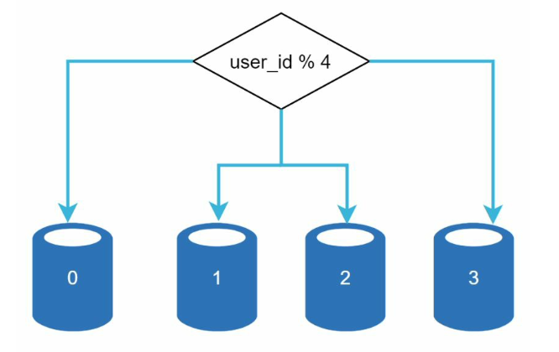

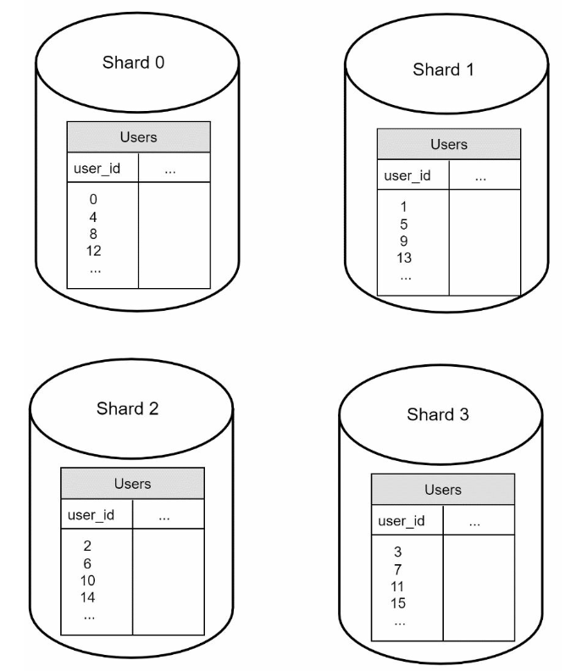

The most important factor to consider when implementing a sharding strategy is the choice of the sharding key. Sharding key (known as a partition key) consists of one or more columns that determine how data is distributed. In the example above user_id is sharding key

Sharding is a great technique to scale the database but it is far from a perfect solution. It introduces complexities and new challenges to the system:

**Resharding data**: Resharding data is needed when 1) a single shard could no longer hold more data due to rapid growth. 2) Certain shards might experience shard exhaustion faster than others due to uneven data distribution. When shard exhaustion happens, it requires updating the sharding function and moving data around. Consistent hashing, which will be discussed in Chapter 5, is a commonly used technique to solve this problem.

**Celebrity problem**: This is also called a hotspot key problem. Excessive access to a specific shard could cause server overload. Imagine data for Katy Perry, Justin Bieber, and Lady Gaga all end up on the same shard. For social applications, that shard will be overwhelmed with read operations. To solve this problem, we may need to allocate a shard for each celebrity. Each shard might even require further partition.

**Join and de-normalization**: Once a database has been sharded across multiple servers, it is hard to perform join operations across database shards. A common workaround is to de- normalize the database so that queries can be performed in a single table.

<https://www.guru99.com/database-normalization.html>

**Normalization** is a database design technique that reduces data redundancy and eliminates undesirable characteristics like Insertion, Update and Deletion Anomalies. Normalization rules divides larger tables into smaller tables and links them using relationships. The purpose of Normalisation in SQL is to eliminate redundant (repetitive) data and ensure data is stored logically.

In Figure 1-23, we shard databases to support rapidly increasing data traffic. At the same time, some of the non-relational functionalities are moved to a NoSQL data store to reduce the database load.

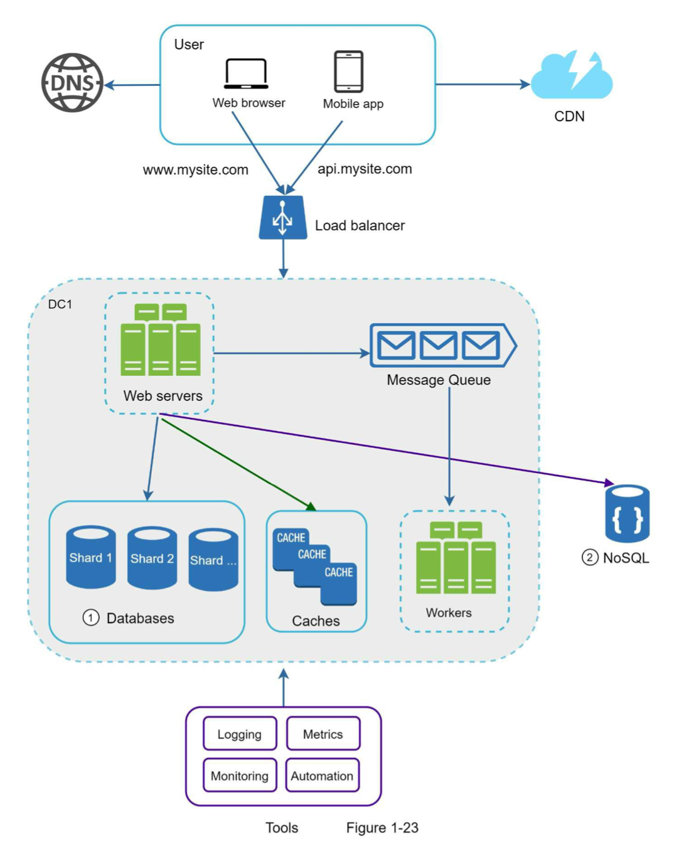

Scaling a system is an iterative process. Iterating on what we have learned in this chapter could get us far. More fine-tuning and new strategies are needed to scale beyond millions of users. For example, you might need to optimize your system and decouple the system to even smaller services.

we provide a summary of how we scale our system to support millions of users:

• Keep web tier stateless

• Build redundancy at every tier

• Cache data as much as you can

• Support multiple data centers

• Host static assets in CDN

• Scale your data tier by sharding

• Split tiers into individual services

• Monitor your system and use automation tools

power of 2: A byte is a sequence of 8 bits. An ASCII character uses one byte of memory (8 bits).

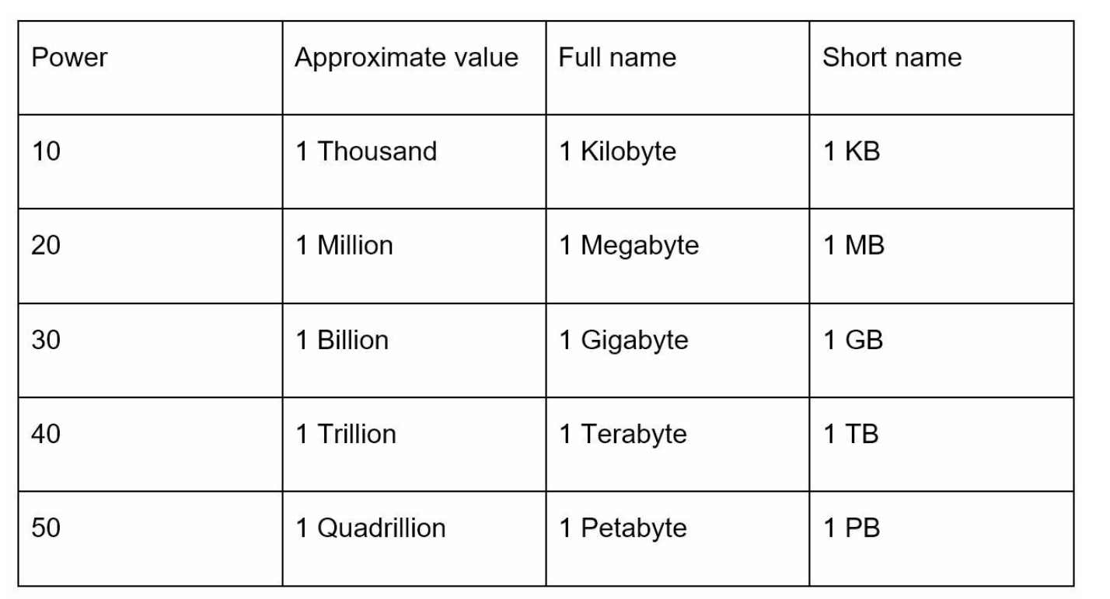

**Latency numbers every programmer should know**

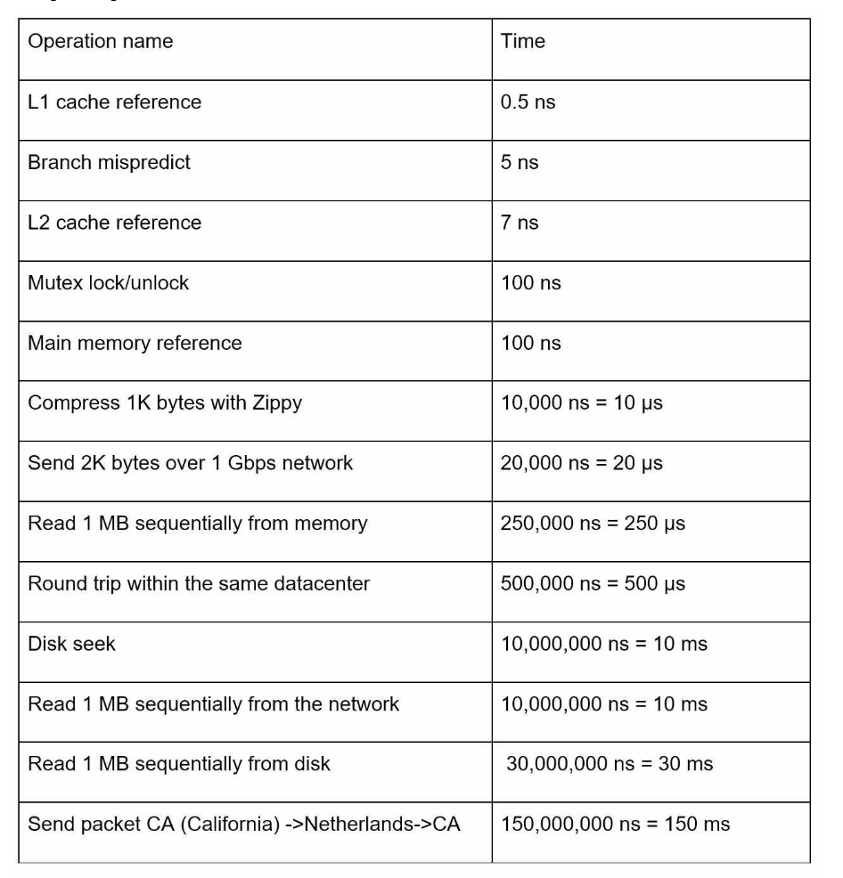

ns = nanosecond, μs = microsecond, ms = millisecond 1 ns = 10^-9 seconds 1 μs= 10^-6 seconds = 1,000 ns 1 ms = 10^-3 seconds = 1,000 μs = 1,000,000 ns

• Memory is fast but the disk is slow.

• Avoid disk seeks if possible.

• Simple compression algorithms are fast.

• Compress data before sending it over the internet if possible.

• Data centers are usually in different regions, and it takes time to send data between them.

**Availability numbers**

High availability is the ability of a system to be continuously operational for a desirably long period of time. High availability is measured as a percentage, with 100% means a service that has 0 downtime. Most services fall between 99% and 100%.

A service level agreement (SLA) is a commonly used term for service providers. This is an agreement between you (the service provider) and your customer, and this agreement formally defines the level of uptime your service will deliver. Cloud providers Amazon [4], Google [5] and Microsoft [6] set their SLAs at 99.9% or above. Uptime is traditionally measured in nines. The more the nines, the better.

Query per second (QPS) estimate:

Assumptions:

• 300 million monthly active users.

• 50% of users use Twitter daily.

• Users post 2 tweets per day on average.

• 10% of tweets contain media.

• Data is stored for 5 years.

• Daily active users (DAU) = 300 million * 50% = 150 million

• Tweets QPS = 150 million * 2 tweets / 24 hour / 3600 seconds = ~3500 • PeekQPS=2*QPS=~7000

We will only estimate media storage here.

• Average tweet size:

• tweet_id 64 bytes

• text 140 bytes

• media 1MB

• Mediastorage:150million*2*10%*1MB=30TBperday

• 5-yearmediastorage:30TB*365*5=~55PB

Back-of-the-envelope estimation is all about the process. Solving the problem is more important than obtaining results. Interviewers may test your problem-solving skills. Here are a few tips to follow:

• Rounding and Approximation. “100,000 / 10” instead of “99987 / 9.1”

• Write down your assumptions.

• Label your units. When you write down “5”, does it mean 5 KB or 5 MB?

• Commonly asked back-of-the-envelope estimations: QPS, peak QPS, storage, cache, number of servers, etc.

The system design interview simulates real-life problem solving where two co-workers collaborate on an ambiguous problem and come up with a solution that meets their goals. The problem is open-ended, and there is no perfect answer. The final design is less important compared to the work you put in the design process. This allows you to demonstrate your design skill, defend your design choices, and respond to feedback in a constructive manner.

An effective system design interview gives strong signals about a person's ability to collaborate, to work under pressure, and to resolve ambiguity constructively. The ability to ask good questions is also an essential skill, and many interviewers specifically look for this skill.

A good interviewer also looks for red flags. **Over-engineering** is a real disease of many engineers as they delight in design purity and ignore tradeoffs. Other red flags include **narrow mindedness, stubbornness**, etc.

Answering without a thorough understanding of the requirements is **a huge red flag** as the interview is not a trivia contest. There is no right answer. So, do not jump right in to give a solution. **Slow down.** Think deeply and ask questions to clarify requirements and assumptions. This is **extremely** important.

One of the most important skills as an engineer is to ask the right questions, make the proper assumptions, and gather all the information needed to build a system. So, do not be afraid to ask questions.

write down your assumptions on the whiteboard or paper. You might need them later.

Here is a list of questions to help you get started:

• What specific features are we going to build?

• How many users does the product have?

• How fast does the company anticipate to scale up? What are the anticipated scales in 3 months, 6 months, and a year?

• What is the company’s technology stack? What existing services you might leverage to simplify the design?